Docker Hands on Part 05

1. Push the Redis images tagged as version 1 and 3 to your Docker Hub repository, named "yourname_cloudethix_redis."

Ans.

root@DESKTOP-1RT156R:~# docker pull redis

Using default tag: latest

latest: Pulling from library/redis

2f44b7a888fa: Already exists

c55535369ffc: Pull complete

3622841bf0aa: Pull complete

91a62ca7377a: Pull complete

fdd219d1f4ab: Pull complete

fdf07fe2fb4c: Pull complete

4f4fb700ef54: Pull complete

fba604e70bfe: Pull complete

Digest: sha256:b5ddcd52d425a8e354696c022f392fe45fca928f68d6289e6bb4a709c3a74668

Status: Downloaded newer image for redis:latest

docker.io/library/redis:latest

root@DESKTOP-1RT156R:~# docker image ls

REPOSITORY TAG IMAGE ID CREATED SIZE

108891563677.dkr.ecr.us-east-1.amazonaws.com/my_local_repo v2 f51ec734d7d4 4 days ago 250MB

baigzuber/docker_app_images v1 f51ec734d7d4 4 days ago 250MB

my_dhub_image latest f51ec734d7d4 4 days ago 250MB

my_awscer_image latest ea256e615e41 4 days ago 250MB

108891563677.dkr.ecr.us-east-1.amazonaws.com/my_local_repo v1 ea256e615e41 4 days ago 250MB

baigzuber/docker_app_images v2 ea256e615e41 4 days ago 250MB

baigzuber/my_docker_repo latest c51b8dc8d670 4 days ago 187MB

**redis latest bdff4838c172 2 weeks ago 138MB**

root@DESKTOP-1RT156R:~# docker image tag redis baigzuber/cloud_redis:v1

root@DESKTOP-1RT156R:~# docker image ls

REPOSITORY TAG IMAGE ID CREATED SIZE

108891563677.dkr.ecr.us-east-1.amazonaws.com/my_local_repo v2 f51ec734d7d4 4 days ago 250MB

baigzuber/docker_app_images v1 f51ec734d7d4 4 days ago 250MB

my_dhub_image latest f51ec734d7d4 4 days ago 250MB

108891563677.dkr.ecr.us-east-1.amazonaws.com/my_local_repo v1 ea256e615e41 4 days ago 250MB

baigzuber/docker_app_images v2 ea256e615e41 4 days ago 250MB

my_awscer_image latest ea256e615e41 4 days ago 250MB

baigzuber/my_docker_repo latest c51b8dc8d670 4 days ago 187MB

**baigzuber/cloud_redis v1 bdff4838c172 2 weeks ago 138MB**

redis latest bdff4838c172 2 weeks ago 138MB

root@DESKTOP-1RT156R:~# docker image tag redis baigzuber/cloud_redis:v3

root@DESKTOP-1RT156R:~# docker image ls

REPOSITORY TAG IMAGE ID CREATED SIZE

my_dhub_image latest f51ec734d7d4 4 days ago 250MB

108891563677.dkr.ecr.us-east-1.amazonaws.com/my_local_repo v2 f51ec734d7d4 4 days ago 250MB

baigzuber/docker_app_images v1 f51ec734d7d4 4 days ago 250MB

my_awscer_image latest ea256e615e41 4 days ago 250MB

108891563677.dkr.ecr.us-east-1.amazonaws.com/my_local_repo v1 ea256e615e41 4 days ago 250MB

baigzuber/docker_app_images v2 ea256e615e41 4 days ago 250MB

baigzuber/my_docker_repo latest c51b8dc8d670 4 days ago 187MB

baigzuber/cloud_redis v1 bdff4838c172 2 weeks ago 138MB

**baigzuber/cloud_redis v3 bdff4838c172 2 weeks ago 138MB**

redis latest bdff4838c172 2 weeks ago 138MB

root@DESKTOP-1RT156R:~# docker image push baigzuber/cloud_redis:v1

The push refers to repository [docker.io/baigzuber/cloud_redis]

cd02e5942a1e: Mounted from library/redis

5f70bf18a086: Mounted from library/redis

fcae66387b13: Mounted from library/redis

cbc573a5c422: Mounted from library/redis

116584210380: Mounted from library/redis

c95bcf9f626e: Mounted from library/redis

2361aeb2c69c: Mounted from library/redis

571ade696b26: Mounted from baigzuber/my_docker_repo

v1: digest: sha256:5d5d31a84c7fec11a3c8a29b04b1712f650a98338f6a51152de42459ea24060b size: 1986

root@DESKTOP-1RT156R:~# docker image push baigzuber/cloud_redis:v3

The push refers to repository [docker.io/baigzuber/cloud_redis]

cd02e5942a1e: Layer already exists

5f70bf18a086: Layer already exists

fcae66387b13: Layer already exists

cbc573a5c422: Layer already exists

116584210380: Layer already exists

c95bcf9f626e: Layer already exists

2361aeb2c69c: Layer already exists

571ade696b26: Layer already exists

v3: digest: sha256:5d5d31a84c7fec11a3c8a29b04b1712f650a98338f6a51152de42459ea24060b size: 1986

root@DESKTOP-1RT156R:~#

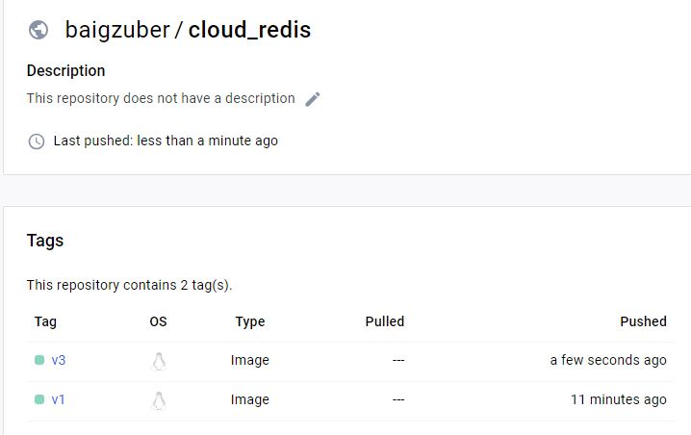

  02 . Create a remote Git repository and add the Dockerfile and index.html files. Clone the repository locally and create a release branch.

- Build the Docker image from the release branch with a meaningful tag, then run a container from the image and expose it on host port 8383.

             - Check the webpage in a browser, and upon success, push the image to your Docker Hub repository named "yourname_cloudethix_nginx."

             - Finally, push the release branch to the remote Git repository and merge it by creating a pull request.

Ans.

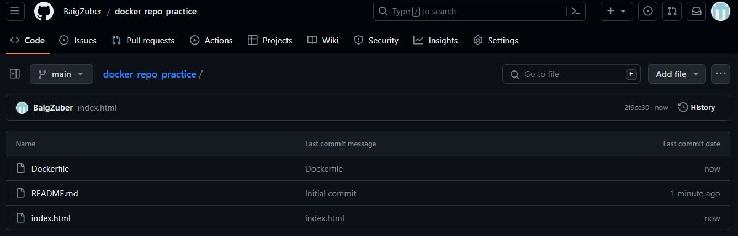

root@DESKTOP-1RT156R:~# git clone git@github.com:BaigZuber/docker_repo_practice.git

Cloning into 'docker_repo_practice'...

remote: Enumerating objects: 8, done.

remote: Counting objects: 100% (8/8), done.

remote: Compressing objects: 100% (5/5), done.

remote: Total 8 (delta 1), reused 0 (delta 0), pack-reused 0

Receiving objects: 100% (8/8), done.

Resolving deltas: 100% (1/1), done.

root@DESKTOP-1RT156R:~# ls -l

total 92

drwxr-xr-x 2 root root 4096 Jan 19 17:10 AWSECR

drwxr-xr-x 2 root root 4096 Jan 19 17:11 DHUB

-rw-r--r-- 1 root root 74 Jan 19 14:25 Dockerfile

drwxr-xr-x 4 root root 4096 Jan 9 13:23 clone

-rw-r--r-- 1 root root 91 Jan 19 15:02 custom-index.html

drwxr-xr-x 2 root root 4096 Jan 1 16:17 dell

drwxr-xr-x 3 root root 4096 Jan 23 23:51 **docker_repo_practice**

drwxr-xr-x 3 root root 4096 Jan 3 13:28 git_repo1

drwxr-xr-x 2 root root 4096 Jan 1 16:17 hp

-rw-r--r-- 1 root root 51 Jan 23 15:41 index.html

drwxr-xr-x 2 root root 4096 Jan 1 16:19 lenovo

-rw-r--r-- 1 root root 1675 Jan 18 19:52 nic_key.pem

drwxr-xr-x 3 root root 4096 Jan 3 12:50 project

drwxr-xr-x 3 root root 4096 Jan 3 13:10 project1

drwxr-xr-x 3 root root 4096 Jan 3 16:12 project3

drwxr-xr-x 3 root root 4096 Jan 3 14:43 project4

drwxr-xr-x 4 root root 4096 Jan 9 12:51 project_clone

drwxr-xr-x 4 root root 4096 Jan 10 22:24 project_lan

drwxr-xr-x 4 root root 4096 Jan 10 23:14 project_lan1

drwxr-xr-x 3 root root 4096 Jan 4 14:07 project_repo

drwxr-xr-x 3 root root 4096 Jan 4 13:09 tmp

drwxr-xr-x 4 root root 4096 Jan 10 22:22 ubuntu-nginxx

-rw-r--r-- 1 root root 667 Jan 1 15:28 zuber.tar.gz

root@DESKTOP-1RT156R:~# cd docker_repo_practice/

root@DESKTOP-1RT156R:~/docker_repo_practice# ls -l

total 12

-rw-r--r-- 1 root root 1 Jan 23 23:51 Dockerfile

-rw-r--r-- 1 root root 22 Jan 23 23:51 README.md

-rw-r--r-- 1 root root 1 Jan 23 23:51 index.html

root@DESKTOP-1RT156R:~/docker_repo_practice# git branch

* main

root@DESKTOP-1RT156R:~/docker_repo_practice# git checkout -b release

Switched to a new branch 'release'

root@DESKTOP-1RT156R:~/docker_repo_practice# git branch

main

* release

03. Save all local Redis images as a .tar file in the master branch of your local repository.

            -  Delete all Redis images from your local system and push the master branch to the remote repository.

-  Load the Redis images from the tar file to your local system, and verify that all images have been loaded correctly.

Ans.

04. Pull the Busy-box image to your local system, tag it, and push it to the Docker Hub repository "yourname_cloudethix_busybox."

- Export the Docker image from the NGINX container, create a .tar file, and import the tar file to create a Docker image with a meaningful name.

- After importing the image, tag it and push it to the "yourname_cloudethix_busybox" Docker Hub repository.

Ans.

05. Dockerfile creation: Create a simple Dockerfile to build a custom image with the following specifications:  
  - Base image: Ubuntu  
  - Install packages: curl, vim, and git  
     - Set an environment variable: MY_NAME=Your_Name  
  - Build the custom image using docker build and list all available images using docker images.

Ans.